Task 1: Python File Handling and Automation

Internship:
Python Developer Internship – Alfido Tech

Objective:
The objective of this task is to demonstrate Python file handling operations including creating, writing, reading, renaming, and moving files using Python. Exception handling is also implemented to manage errors effectively.

Tools Used:
- Python
- IDLE Python
- GitHub

Program Description:
This program:
1. Creates a text file.
2. Writes task details into the file.
3. Reads and displays file contents.
4. Renames the file.
5. Moves the file into a separate folder.
6. Uses exception handling to manage errors.
Source Code:
# Internship Task Tracker
# Python File Handling and Automation Project
# Demonstrates file operations and exception handling

import os
import shutil

try:
# Create task file
task_file = "alfido_tasks.txt"

with open(task_file, "w") as file:
file.write("Task 1 - Python File Handling - Completed\n")
file.write("Task 2 - API Integration - Pending\n")
file.write("Task 3 - Data Analysis - Pending\n")

print("Task file created successfully.")

# Read file contents
print("\nCurrent Internship Tasks:")

with open(task_file, "r") as file:
content = file.read()
print(content)

# Rename file
renamed_file = "alfido_progress_report.txt"
os.rename(task_file, renamed_file)

print("File renamed successfully.")

# Move file to folder
destination_folder = "Completed_Tasks"

if not os.path.exists(destination_folder):
os.mkdir(destination_folder)

shutil.move(
renamed_file,
os.path.join(destination_folder, renamed_file)
)

print("File moved to Completed_Tasks folder.")

except FileNotFoundError:
print("Error: File not found.")

except PermissionError:
print("Error: Permission denied.")

except Exception as e:
print("Unexpected Error:", e)

Output:

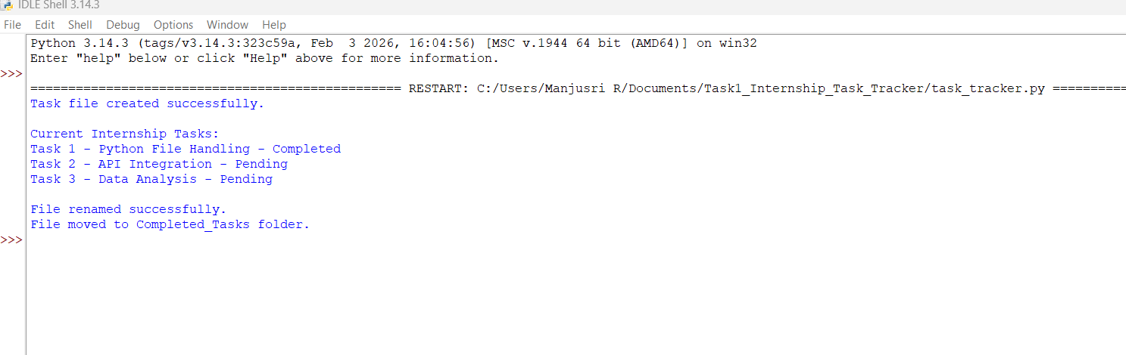

Project Structure:

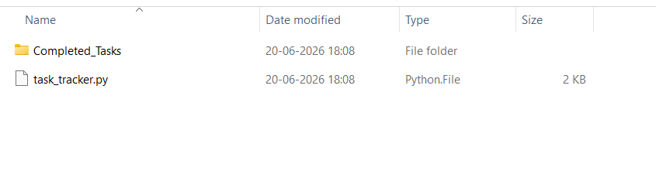

Generated Report File:

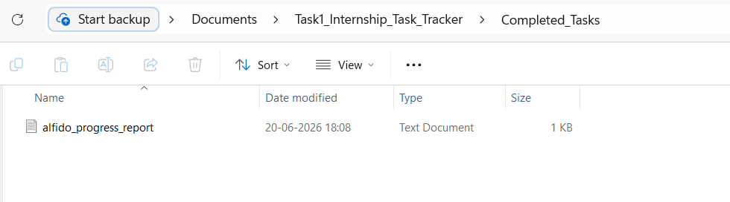

GitHub Repository Link:

https://github.com/Manjusri3037/Alfido-Tech-Internship

Conclusion

The task was successfully completed using Python file handling and automation techniques. All required operations were implemented and tested successfully.

